# EvaluationGroup, LLC

**Statewide Health Improvement Program**

**&**

**Tobacco Free Communities**

**Summary of**

**Youth Behavioral Risk Statistics**

**Quin County Community Health Services**

January

2015

Authored by

Garth Kruger, Ph.D.

EvaluationGroup,LLC • 29337 310th Ave NW • Warren, MN 56762

Tel (218) 437-8435 • e-mail *gkruger@evaluationgroupllc.com*

**Minnesota Student Survey 2007-2013**

**Quin County Community Health Services**

**Summary of Findings:**

**Overweight/Obese**

* Youth residing in the 12 county SHIP region are significantly (statistically) more overweight than other youth from across the state (16.6% vs. 12.5%).
  + In the Quin CHS service area, Marshall County has the highest average percent of youth overweight at 20.2% and Kittson County the lowest at 10.3%.
* Findings indicate that youth in the SHIP region are significantly more obese than those youth from across the state (12.2% vs. 9.6%).
  + Pennington County has the highest average percentage of youth obese at 17.9%; Roseau County has the lowest (12.2%).

**Physical Activity**

* The percentage of youth who engage in ‘no weekly physical activity’ is lower (9.3%) than the rest of the state (12.4%), which is a positive finding.
  + MNSS data do not exist for examining adequate physical activity levels over time in the region as the metrics for measuring such activity have changed.

**Fresh Fruit/Vegetable Consumption**

* Consumption of five or more servings of fresh fruits and vegetables per day in 2013 in the SHIP region was significantly (statistically) lower (13.5%) than that consumed by the rest of Minnesota youth (17.7%).
  + In the Quin CHS service area Pennington County had the highest percentage of youth consuming fruits/vegetables at 15%; Kittson was the lowest at 9.7%.

**Tobacco Use**

* Use of any tobacco product over the past 30 days in the SHIP region at (23.9%) is significantly (statistically) higher compared to what is found across the rest of the state (state average 18.8%).
  + Roseau County 30 day tobacco use is much higher than other counties at 32.7; the lowest is in Red Lake County at 16.7%.
* Smokeless tobacco use in the region is nearly twice the state average (13.2% vs. 7.6%),
  + Smokeless tobacco use is highest in Roseau County (24.7%) and lowest in Kittson (7.5%).
  + In general, over 90% of smokeless tobacco users tend to be male.

*Youth Weight Trends*



* Youth residing in the 12 county SHIP region are significantly (statistically) more overweight than other youth from across the state. (16.6% vs. 12.5%).
  + In the Quin service area, Marshall County has the highest average percent of youth overweight at 20.2% and Kittson County the lowest at 10.3%.



* Findings indicate that youth in the SHIP region are significantly more obese than those youth from across the state (12.2% vs. 9.6%).
  + In the Quin service area, Kittson County has the highest average percentage of youth obese at 17.9%; Roseau County has the lowest (12.2%).

*Physical Activity*



* The percentage of youth in who engage in ‘no weekly physical activity’ is highest (worst) in Marshall County at 11.6% and lowest (best) in Kittson County (7.3%). Regionally, all counties are lower (better) than the rest of the state at (12.4%), which is a positive finding.
* 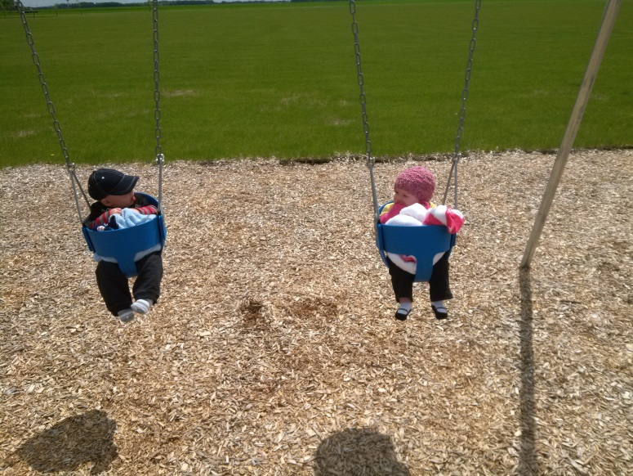MNSS data do not exist for examining adequate physical activity levels over time as the metrics have changed. In 2007 and 2010, adequate physical activity definitions included identifying 12th graders who reported ‘participating in either vigorous physical activity for 20 or more minutes per day on 3 or more days in the past 7 days or moderate physical activity for 30 or more minutes per day on 5 or more days in the past 7 days’. Current physical activity guidelines assessed 11th graders and asked: ‘During the last 7 days, on how many days were you physically active for a total of at least 60 minutes per day?’ Making comparisons between these data over time was not appropriate.
* Current U.S. Department of Health and Human Service guidelines recommend 60 minutes per day at least 3 days a week of either moderate or vigorous intensity. [www.health.gov/paguidelines/guidelines/summary.aspx](http://www.health.gov/paguidelines/guidelines/summary.aspx)

*Consumption of Fruits and Vegetables*



* Consumption of five or more servings of fresh fruits and vegetables per day in 2013 in the SHIP region (13.5%) was significantly (statistically) lower than that consumed by the rest of Minnesota youth (17.7%).
  + Kittson County had the highest percentage of youth consuming fruits/vegetables at 15%; Marshall County was the lowest at 9.7%.
  + Renewed efforts to improve fresh fruit and vegetable consumption opportunities for youth is warranted.

**

*Tobacco Use*



* Use of any tobacco product over the past 30 days in the SHIP region at (23.9%) is significantly (statistically) higher compared to what is found across the rest of the state (state average 18.8%).
  + Roseau County 30 day tobacco use is much higher than other counties at 32.7; the lowest is in Red Lake County at 16.7%.



* Smokeless tobacco use in the region is nearly twice the state average (13.2% vs. 7.6%),
  + In general, over 90% of smokeless tobacco users tend to be male.
* Smokeless tobacco use is highest in Roseau County (24.7%) and lowest in Kittson (7.5%).

**Minnesota Student Survey Methodology**

The Minnesota Student Survey (MSS) is a triennial survey of young people regarding a variety of risk and protective factors. The survey asks young people questions about their activities, opinions, behaviors and experiences. It includes questions on an array of priority health-risk behaviors including tobacco use, dietary habits, physical inactivity, substance abuse, school climate, violence and safety concerns, out-of-school activities, and connections to school, community and family.

The survey is administered in schools, alternative learning centers and juvenile correctional facilities across the state. The purpose of the survey has been to:

* Provide data for program planning and evaluation.
* Meet state and federal student survey requirements.
* Address relevant issues confronting students.
* Mark trends over time.
* Involve schools/other educational settings statewide and provide data for local use.

The 2013 MSS was administered in the first half of 2013 to public school students in grades 5, 8, 9 and 11, statewide. All public school districts in Minnesota were invited to participate. Of the 334 public operating districts, 280 agreed to participate (84 percent of public operating school districts).

The survey's methodology changed in 2013 in ways that make it challenging to compare some of the latest results to previous years. From 1992 to 2010, the state surveyed 6th, 9th and 12th graders. In 2013 that changed to 5th, 8th, 9th and 11th graders. Furthermore, a large number of questions were either changed, omitted or added. To the extent that it was possible, variables on the 2013 MNSS were combined or parsed to extract data points that matched responses from previous iterations of the MNSS. The result was that 6 items of interest could be traced back through the 2007 administration and those data, in addition to other enlightening information is included in this review.

The description of behavioral health risks in youth for the SHIP Region is based on the culmination of 2013 Minnesota Student Survey data. In 2013 11th grade student data is presented. Data from older youth is used as they show by far the greatest prevalence of health risk behaviors compared to younger grades. Data on grade 11 and 12 students is deemed to be a relevant and succinct representation of county youth needs given the parameters of the SHIP intervention guidelines.

Public school student participation was voluntary and surveys were anonymous. Across the state, approximately 66 percent of fifth graders, 71 percent of eighth graders, 69 percent of ninth graders and 62 percent of eleventh graders participated in the 2013 MSS. Overall participation across the four grades was approximately 67 percent of total enrollment.

All schools and districts that participated in the survey followed federal laws regarding parental notification as required by the Family Educational Rights and Privacy Act (FERPA) and the Protection of Pupil Rights Amendment (PPRA). PPRA requires that schools that participate in the survey notify parents of the survey administration, provide parents the opportunity to review the survey instrument, and allow parents to opt their child out of participating.

EvaluationGroup, LLC staff contacted the MN Student Survey administrators and obtained a copy of the raw dataset for further analysis which were used in this report. We are indebted to their generosity for permitting us use of this data in pursuit of improving health in Minnesotans. The survey is made possible through a partnership between the Minnesota Departments of Education, Health, Human Services and Public Safety. These agencies provide funding and staff time to develop, administer and analyze the survey.

Comparisons between county level percentages and state percentages also include a benchmark SHIP Region percentage value. The SHIP region data includes data from all 12 counties who have been involved in either SHIP and/or CTG since 2009 and include the counties of Roseau, Marshall, Kittson, Lake of the Woods, Red Lake, Pennington, Polk, Mahnomen, Norman, Clearwater, Beltrami and Hubbard.